 |  |  |  | Value3 | Value2 | Value1 |  | Event Name in Event Table | Event Alias
 |  |  |  |  |  | rrc.nas_Message": "83:25:02:e0:9c | rrc→rrc.DL_DCCH_Message_element→rrc.message_tree | NAS Message | NAS Message
 |  |  |  |  |  | gsm_a.rr.timing_adv": 1 | gsm_a.dtap→ Timing Advance | Timing Advance | Timing Advance
 |  |  |  |  |  | lte-rrc.srb_ToAddModList": "1 | lte_rrc → lte-rrc.rrcConnectionSetup_element→ lte-rrc.radioResourceConfigDedicated_element | LTE RRC SRB | No. of RABs
 |  |  |  | lte-rrc.n2TxAntenna_tm4": fc | lte-rrc.codebookSubsetRestriction": 2 | Lte-rrc.transmission mode: 3 | lte_rrc → lte-rrc.rrcConnectionSetup_element→ lte-rrc.antennaInfo_tree  یا  lte_rrc → lte-rrc.rrcConnectionReconfiguration_element → lte-rrc.antennaInfo_tree | LTE RRC Antenna Info | Antenna Info
 |  | lte-rrc.antennaPortsCount": "1 | lte-rrc.ue_TransmitAntennaSelection": "0 | lte-rrc.transmissionMode_r10":3 | lte-rrc.referenceSignalPower": 1 | lte-rrc.antennaPortsCount:1 | lte_rrc→ lte-rrc.rrcConnectionSetup_element→ lte-rrc.radioResourceConfigDedicatedSCell_r10_element  یا  lte_rrc→ lte-rrc.rrcConnectionReconfiguration_element → lte-rrc.radioResourceConfigDedicatedSCell_r10_element | LTE RRC Scell
 |  |  |  |  |  |  | 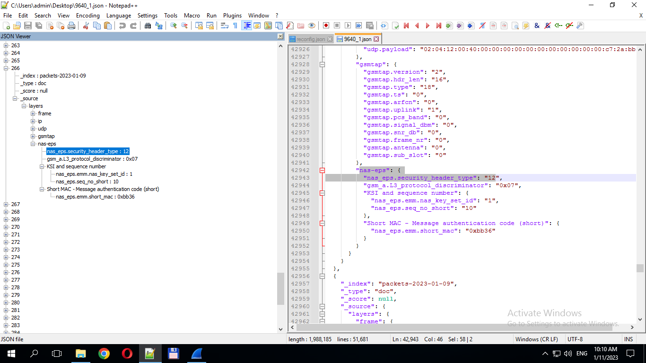  nas-eps→ nas_eps.security_header_type: 12 | Service request | Eps bearer req
 |  |  |  |  | lte-rrc.a1_Threshold_tree": "lte-rrc.threshold_RSRQ": "7" | lte-rrc.a1_Threshold": "1" | lte_rrc lte-rrc.ReportConfigToAddMod_element → lte-rrc.eventA1_element | RRC event A1 | A1 event
 |  |  |  |  | lte-rrc.a2_Threshold_tree": "lte-rrc.threshold_RSRQ": "1" | lte-rrc.a2_Threshold": "1" | lte_rrc→ lte-rrc.ReportConfigToAddMod_element → lte-rrc.eventA2_element | RRC event A2 | A2 event
lte-rrc.triggerType": "0 | lte-rrc.reportAmount": "7 | lte-rrc.reportInterval": "6" | lte-rrc.reportQuantity": "1" | lte-rrc.triggerQuantity": "1" | lte-rrc.timeToTrigger": "1" | lte-rrc.hysteresis": "2" | lte_rrc→ lte-rrc.ReportConfigToAddMod_element | RRC Event hystersis
 |  |  |  |  | lte-rrc.reportOnLeave": "0 | lte-rrc.a3_Offset": "6 | lte_rrc→ lte-rrc.ReportConfigToAddMod_element →lte-rrc.eventA3_element | RRC event A3 | A3 event
 |  |  |  |  |  |  | lte_rrc→lte-rrc.ReportConfigToAddMod_element→lte-rrc.eventA4_element | RRC event A4 | A4 event
 |  |  | lte-rrc.a5_Threshold2_tree": "lte-rrc.threshold_RSRQ": "3" | lte-rrc.a5_Threshold2": "1 | lte-rrc.a5_Threshold1_tree": "lte-rrc.threshold_RSRQ": "17" | lte-rrc.a5_Threshold1": "1 | lte_rrc→ lte-rrc.ReportConfigToAddMod_element →lte-rrc.eventA5_element | RRC event A5 | A5 event
 |  |  |  |  | lte-rrc.a6_ReportOnLeave_r10": 0 | lte-rrc.a6_Offset_r10": "6 | lte_rrc→ lte-rrc.ReportConfigToAddMod_element→lte-rrc.eventA6_r10_element | RRC event A6 | A6 event
 |  |  |  |  |  |  | lte_rrc→ lte-rrc.ReportConfigToAddMod_element→lte-rrc.eventB1_element | RRC event B1 | B1 event
 |  |  |  |  |  |  | lte_rrc→ lte-rrc.ReportConfigToAddMod_element→lte-rrc.eventB1-NR_element | RRC event B1-NR | B1-NR event
 |  |  |  |  |  |  | lte_rrc→ lte-rrc.ReportConfigToAddMod_element→lte-rrc.eventB2_element | RRC event B2 | Event B2
 |  |  |  |  |  |  | lte_rrc→ lte-rrc.ReportConfigToAddMod_element→lte-rrc.eventB2-NR_element | RRC event B2-NR | Event B2-NR
 |  |  |  |  |  | rrc.rb_InformationReconfigList": "5 | rrc.DL_DCCH_Message_element→ rrc.specificationMode_tree | WCDMA RB Info
 |  |  |  |  |  |  | 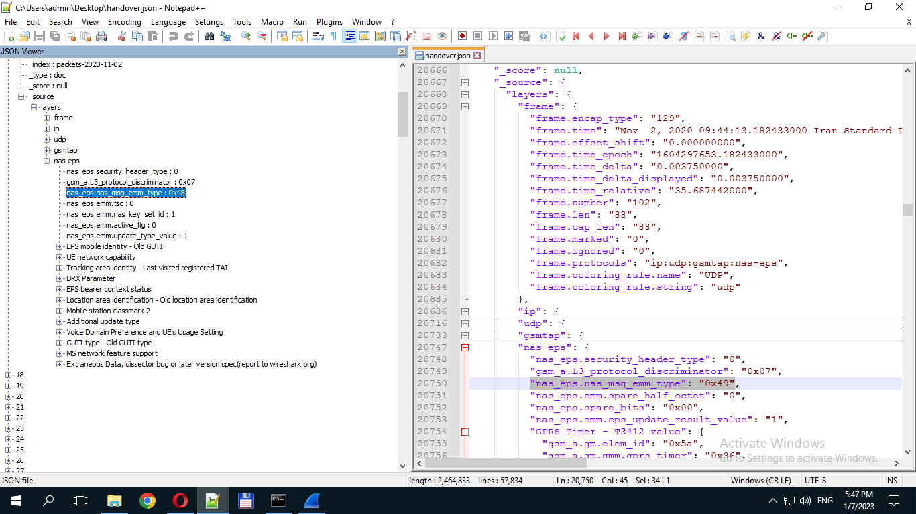 | Tracking area update request | TA update request
 |  |  |  |  |  |  | 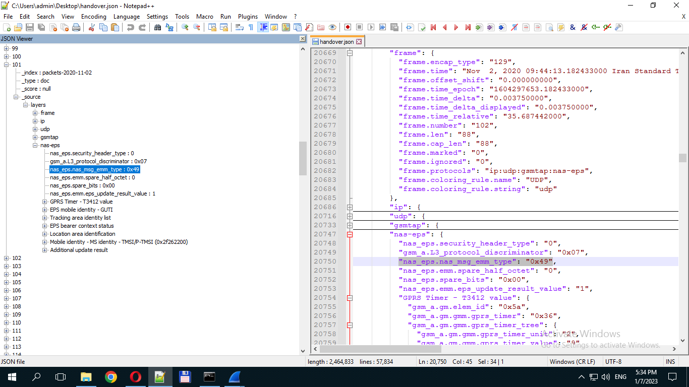 | Tracking area update accept | TA update accept
 |  |  |  |  |  |  | 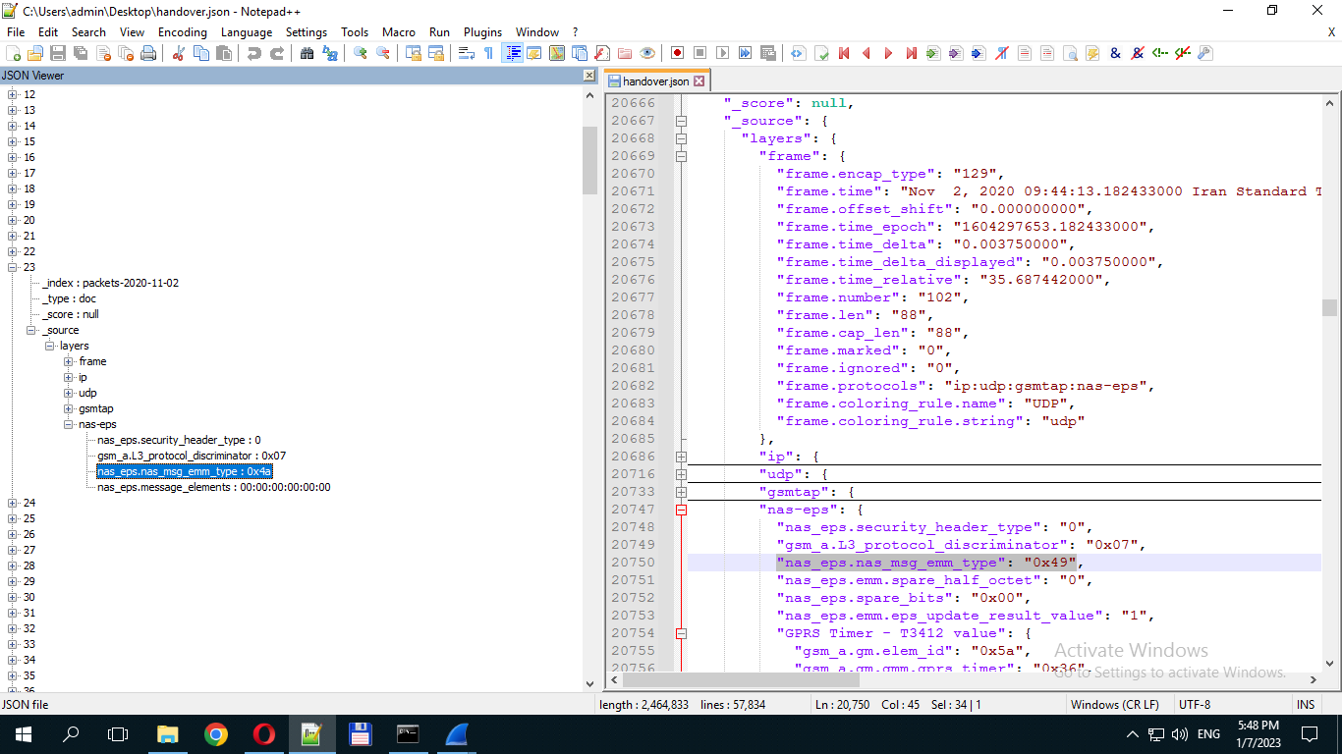 | Tracking area update complete | TA update complete
 |  |  |  |  |  |  | 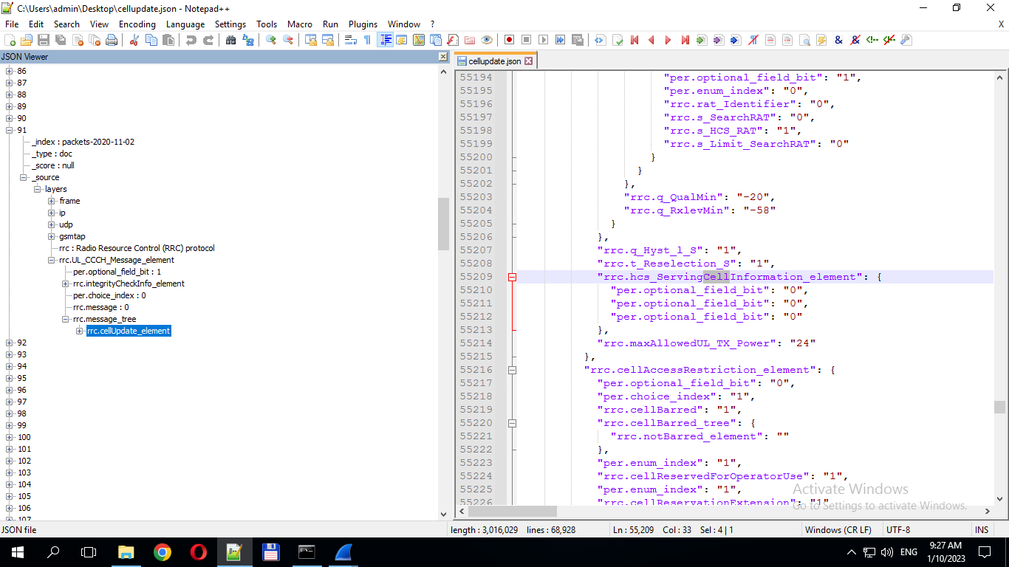 | WCDMA RRC Cell Update | Cell Update  Request
 |  |  |  |  |  |  | 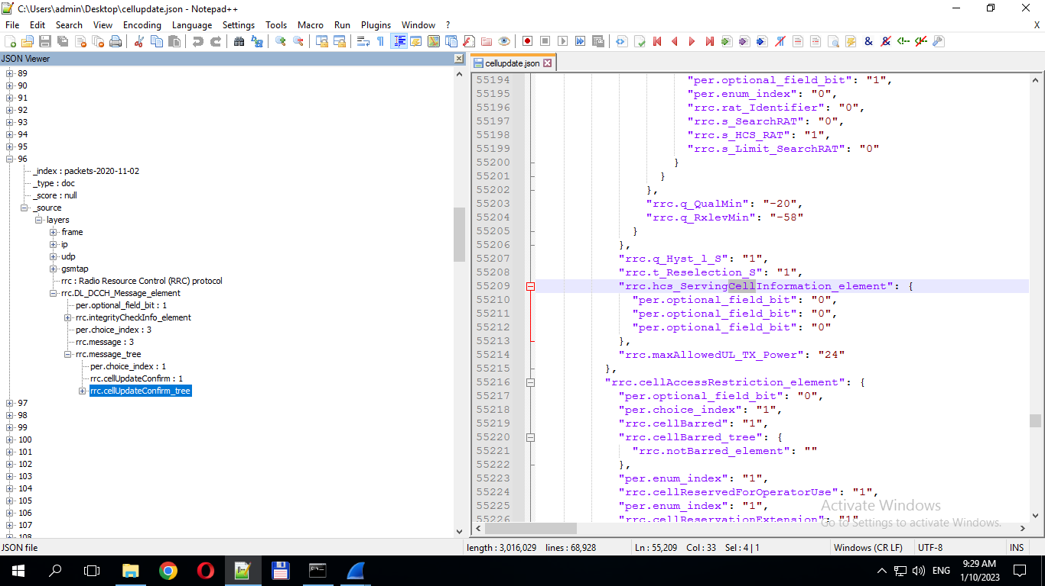 | WCDMA RRC Cell Update Confirm | Cell Update  Confirm
 |  | lte-rrc.ri_ConfigIndex": "322 | lte-rrc.cqi_pmi_ConfigIndex": "127 | lte-rrc.cqi_PUCCH_ResourceIndex": "0" | lte-rrc.cqi_ReportPeriodic": "1" | rrc.cqi_ReportModeAperiodic": "4" | lte_rrc →lte-rrc.rrcConnectionSetup_element →lte-rrc.cqi_ReportConfig_element  یا  lte_rrc →lte-rrc.rrcConnectionReconfiguration_element →lte-rrc.cqi_ReportConfig_element | RRC CQI Report | RRC CQI
 |  |  | lte-rrc.cqi_pmi_ConfigIndex": "127 | lte-rrc.cqi_PUCCH_ResourceIndex_r10": "0 | lte-rrc.cqi_ReportPeriodic_r10": "1 | lte-rrc.cqi_ReportAperiodic_r10": "1 | lte_rrc →lte-rrc.rrcConnectionSetup_element → lte-rrc.cqi_ReportConfig_r10_element  یا  lte_rrc →lte-rrc.rrcConnectionReconfiguration_element→ lte-rrc.cqi_ReportConfig_r10_element | RRC CQI SCC Report | RRC CQI SCC
 |  | Dtx_used : 0 | "gsm_a.rr.rxqual_sub_serv_cell": "0" | "gsm_a.rr.rxqual_full_serv_cell": "0" | "gsm_a.rr.rxlev_sub_serv_cell": "26" | "gsm_a.rr.rxlev_full_serv_cell": "26" | gsm_a.dtap→Measurement Results | GSM Measurement Results
 |  |  |  |  |  |  | 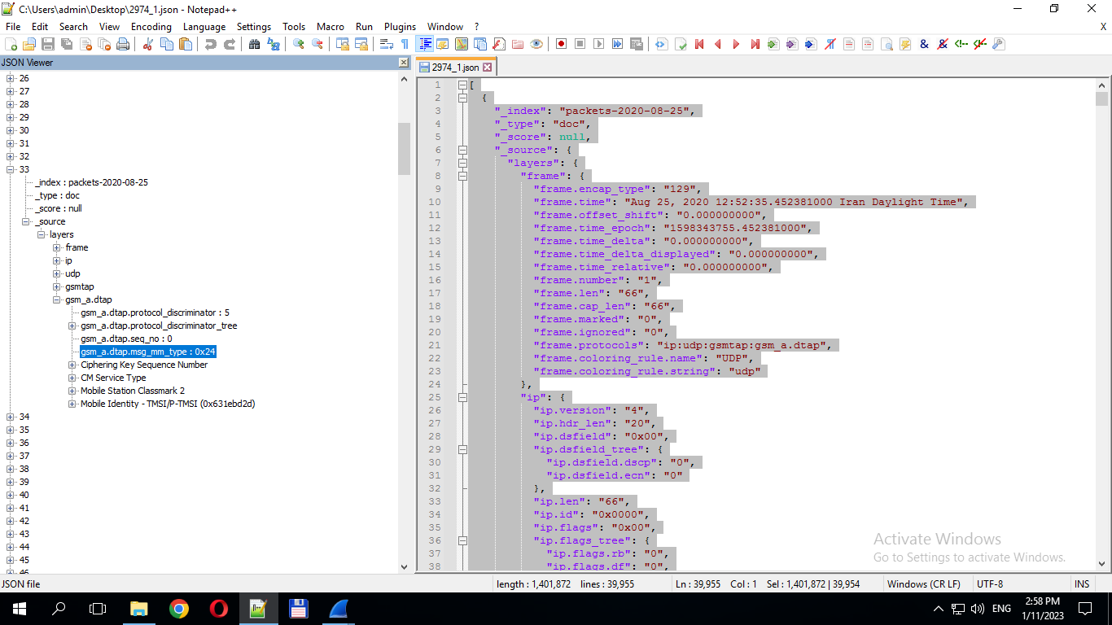 | (DTAP) (MM) CM Service Request | Call Attemp MO
 |  |  |  |  | gsm_a.rr.timeslot": "6 | gsm_a.rr.packet_channel_type": "1 | 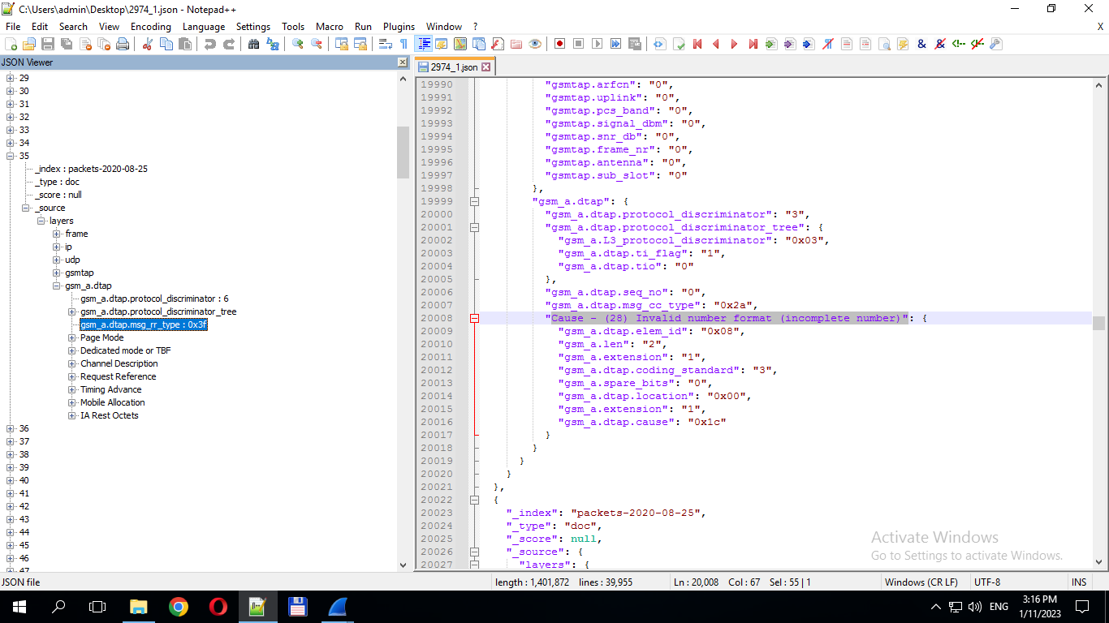 | (DTAP) (RR) Immediate Assignment | Call Establish
 |  |  |  |  |  |  | 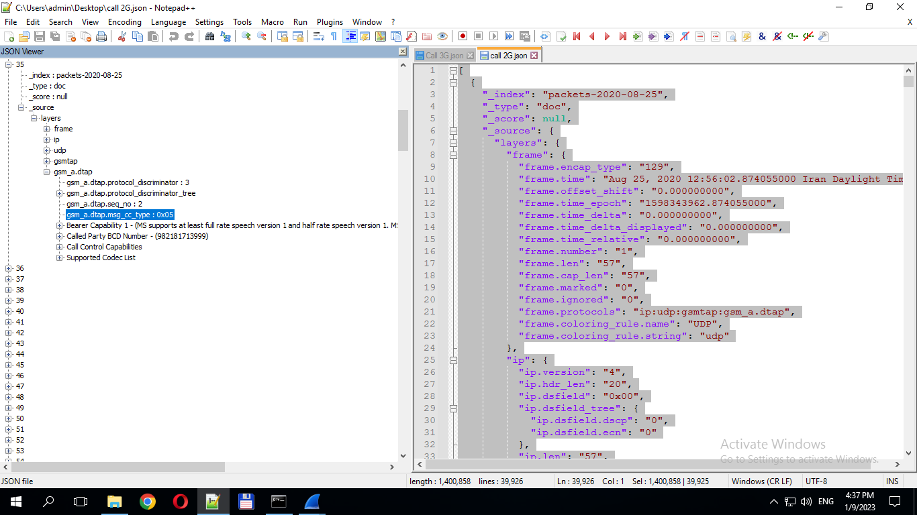 | (CC) Setup | Call Setup
 |  |  |  |  |  |  |  | (CC) Call Confirmed | Call Confirmed
 |  |  |  |  |  |  | 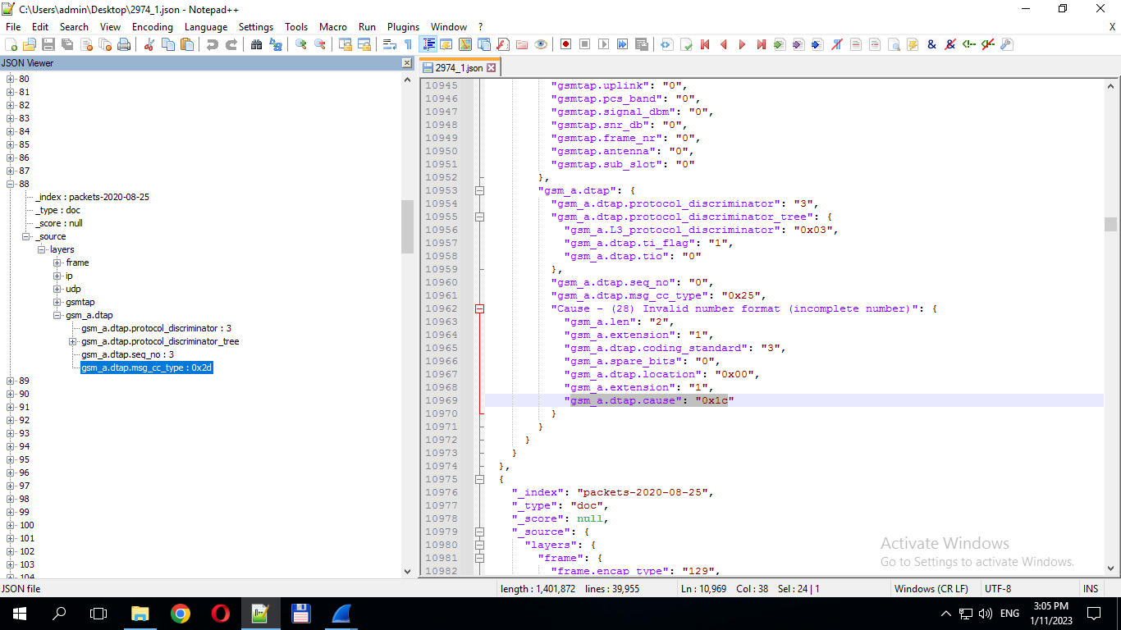 | (CC) Release | Call Release
 |  |  |  |  |  | Cause - (28) Invalid number format (incomplete number)" | 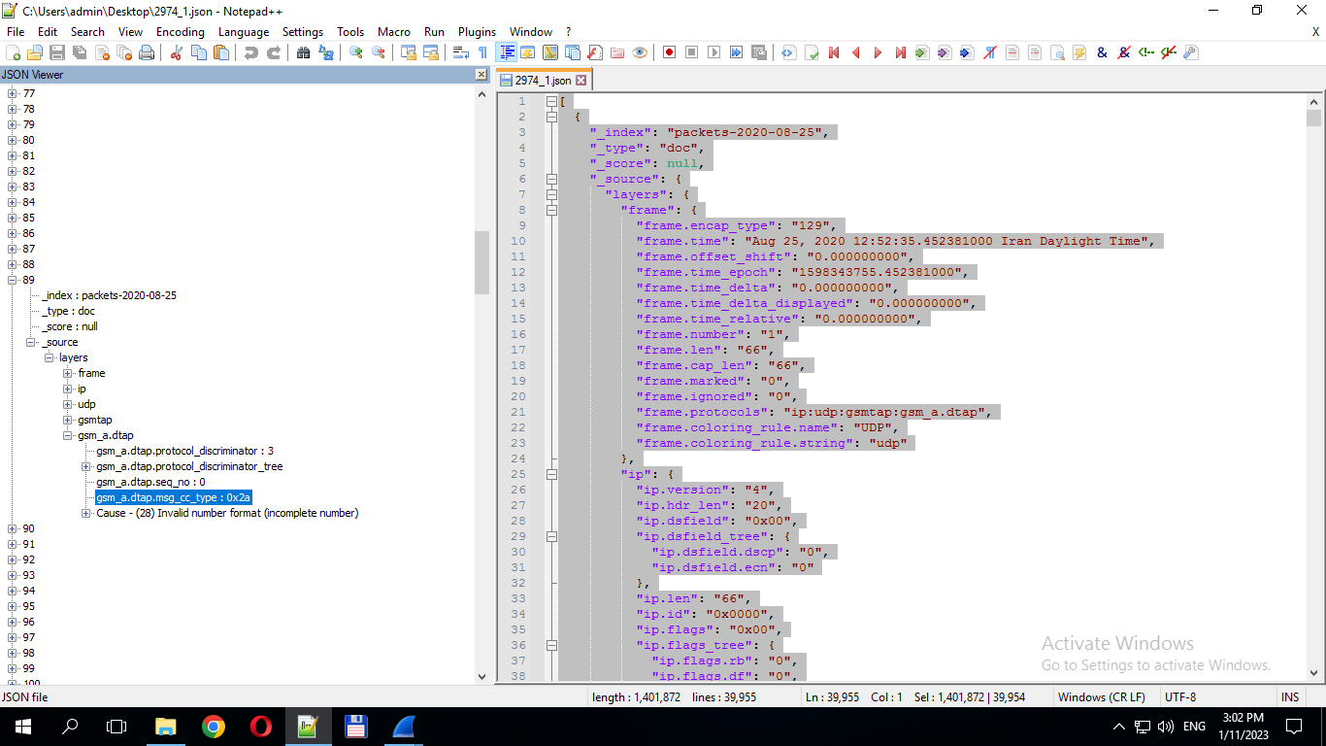 | (CC) Release Complete | Call End
 |  |  |  |  | Codec Bitmap for SysID 2": "gsm_a.dtap.codec.tdma_efr": "0", "gsm_a.dtap.codec.umts_amr_2": "0", "gsm_a.dtap.codec.umts_amr": "0", "gsm_a.dtap.codec.hr_amr": "1", "gsm_a.dtap.codec.fr_amr": "1", "gsm_a.dtap.codec.gsm_efr": "1", "gsm_a.dtap.codec.gsm_hr": "1", "gsm_a.dtap.codec.gsm_fr": "1", "gsm_a.spare_bits": "0", "gsm_a.dtap.codec.umts_evs": "0",  "gsm_a.dtap.codec.ohr_amr_wb": "0", "gsm_a.dtap.codec.ofr_amr_wb": "0", "gsm_a.dtap.codec.ohr_amr": "0", "gsm_a.dtap.codec.umts_amr_wb": "0", "gsm_a.dtap.codec.fr_amr_wb": "0", "gsm_a.dtap.codec.pdc_efr": "0 | Codec Bitmap for SysID 1": "gsm_a.dtap.codec.tdma_efr": "0", "gsm_a.dtap.codec.umts_amr_2": "1", "gsm_a.dtap.codec.umts_amr": "1", "gsm_a.dtap.codec.hr_amr": "0", "gsm_a.dtap.codec.fr_amr": "0", "gsm_a.dtap.codec.gsm_efr": "0", "gsm_a.dtap.codec.gsm_hr": "0", "gsm_a.dtap.codec.gsm_fr": "0",  "gsm_a.spare_bits": "0", "gsm_a.dtap.codec.umts_evs": "0", "gsm_a.dtap.codec.ohr_amr_wb": "0", "gsm_a.dtap.codec.ofr_amr_wb": "0", "gsm_a.dtap.codec.ohr_amr": "0", "gsm_a.dtap.codec.umts_amr_wb": "0", "gsm_a.dtap.codec.fr_amr_wb": "0", "gsm_a.dtap.codec.pdc_efr": "0 | Supported Codec List | Supported Codec List | Codec List for SysID
 |  |  |  |  |  |  | 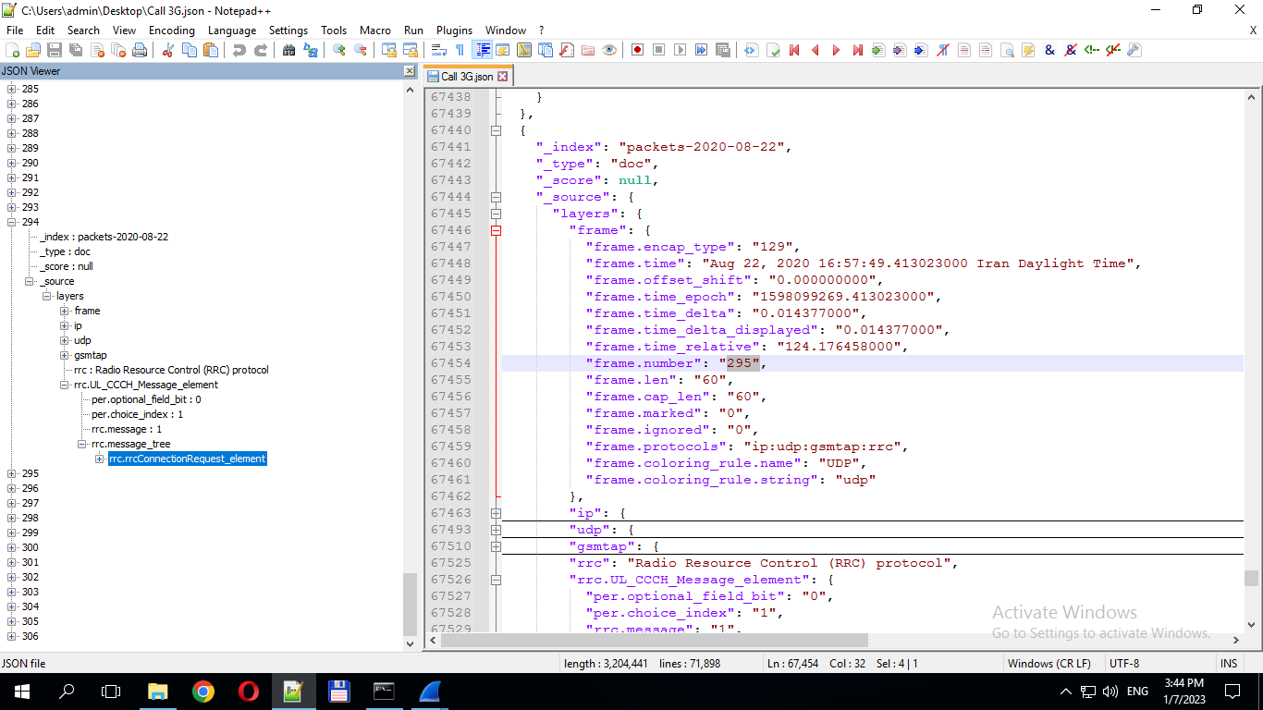 | RRC Connection Request | WCDMA Call Attempt
 |  |  |  |  |  |  | lte_rrc→lte-rrc.rrcConnectionRequest_element | LTE RRC Connection Request
 |  |  |  |  |  |  | 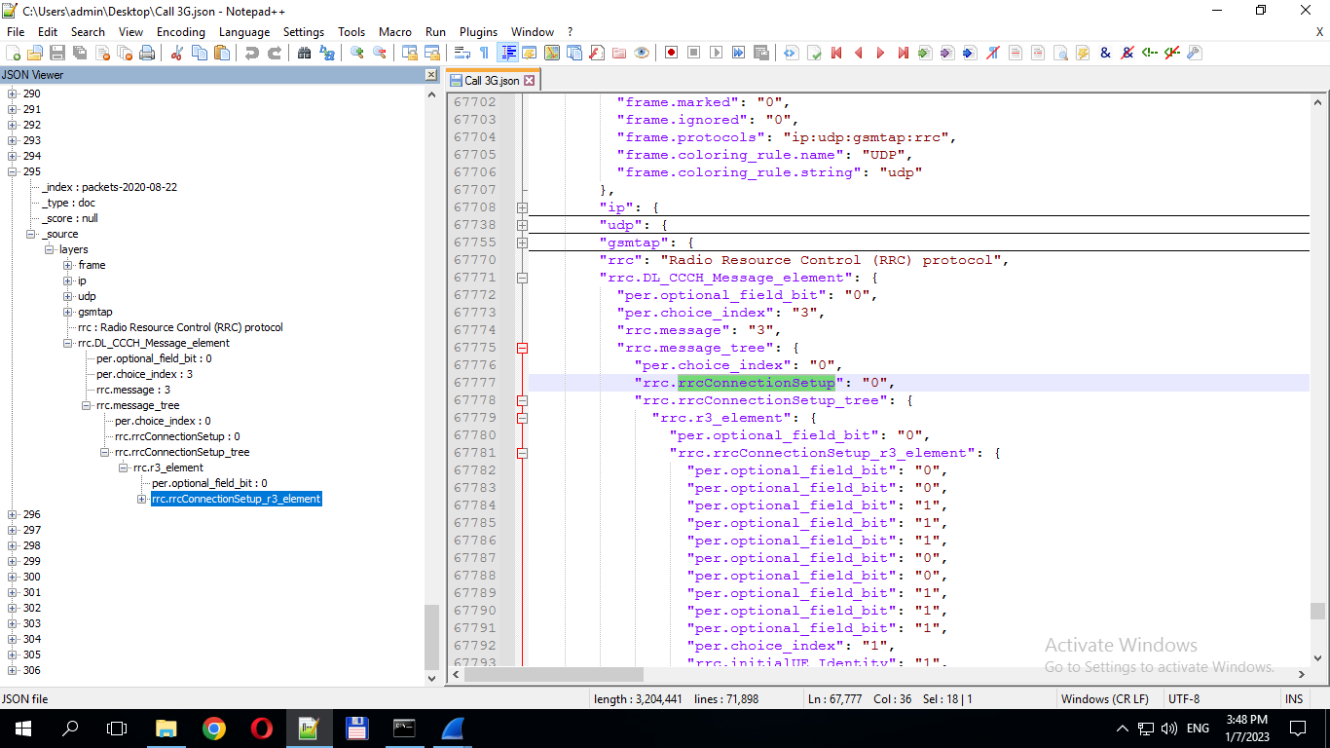 | RCC Connection Setup | 3G Call Establish
 | lte-rrc.allowedMeasBandwidth": "5 | lte-rrc.betaOffset_CQI_Index": "10 | lte-rrc.betaOffset_RI_Index": "9 | lte-rrc.betaOffset_ACK_Index": "10 | lte-rrc.maxHARQ_Tx": "6 | lte-rrc.maxRetxThreshold: 7 | lte_rrc→lte-rrc.rrcConnectionSetup_element | LTE RRC Connection Setup | LTE RRC Connection Setup
 |  |  |  |  |  |  | 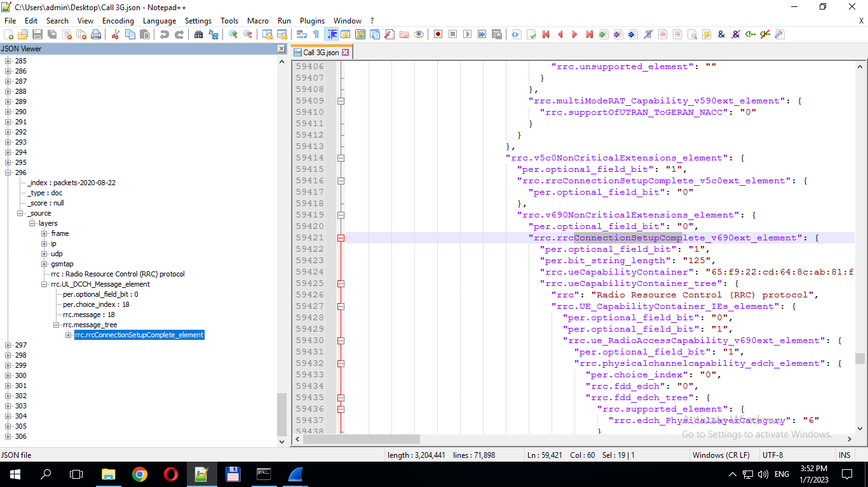 | RRC Connection Setup Complete | Call Initiation
 |  |  |  |  |  |  | 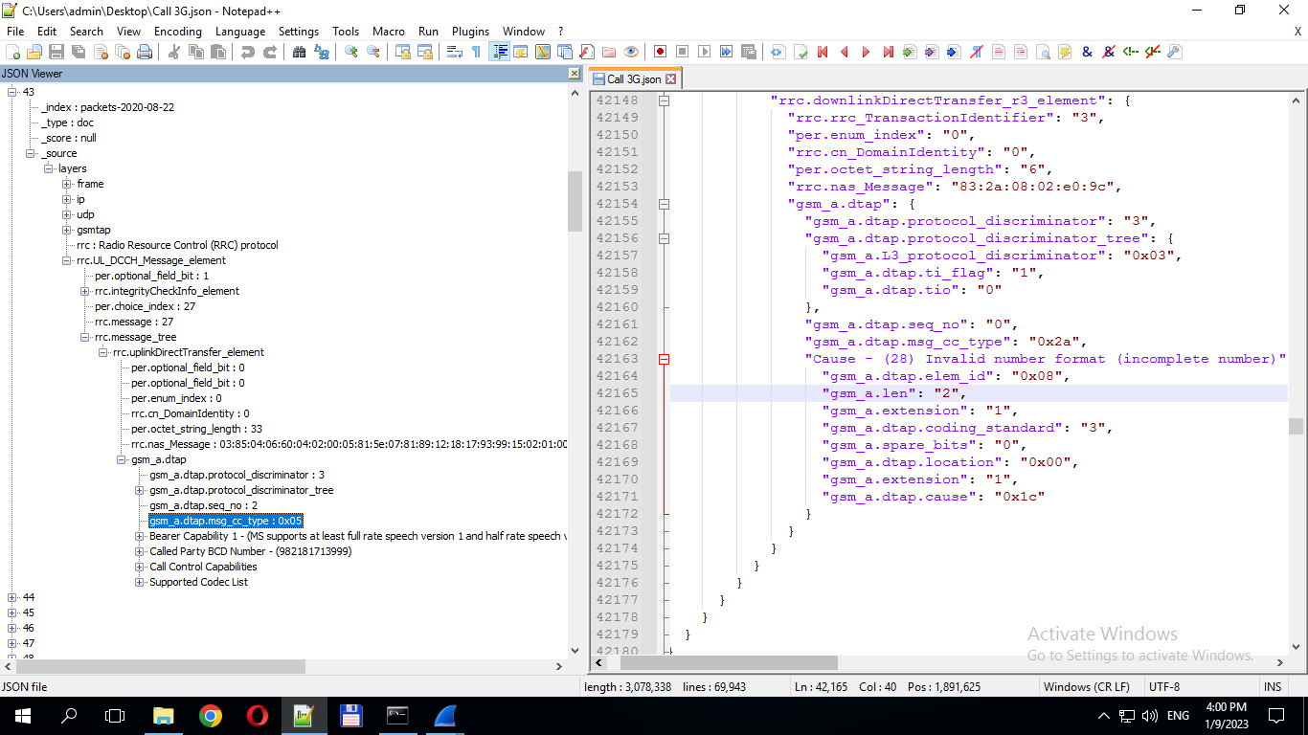 | (CC) Setup | Call Setup
 |  |  |  |  |  |  | 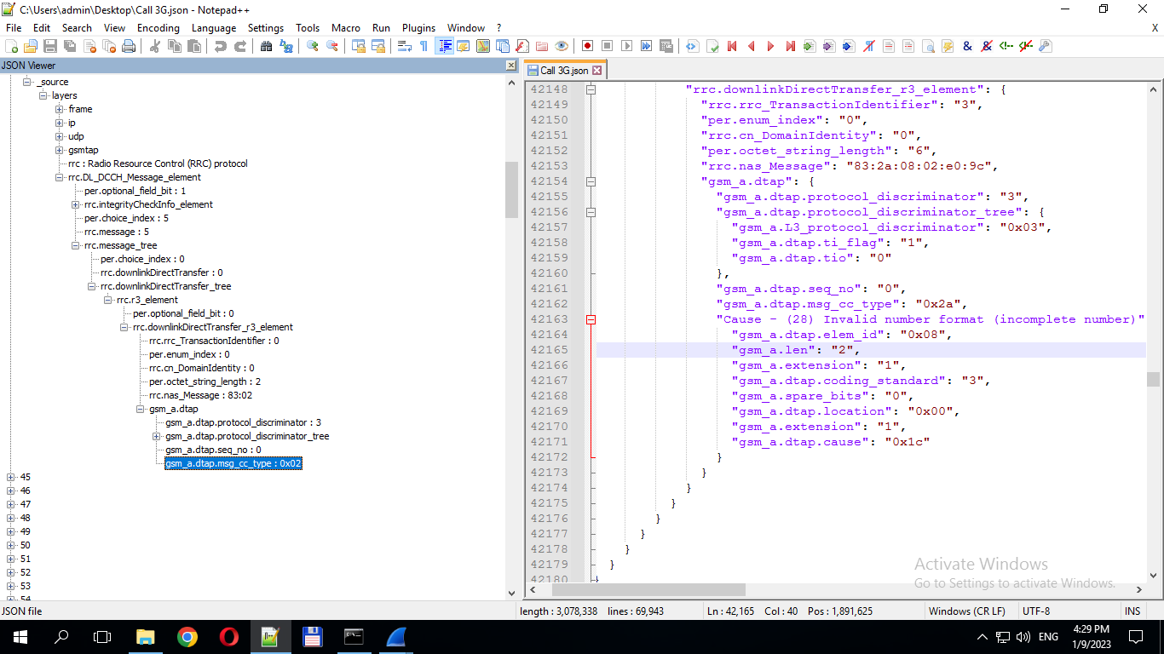 | (CC) Call Proceeding | Call Proceeding(MO)
 |  |  |  |  |  |  | 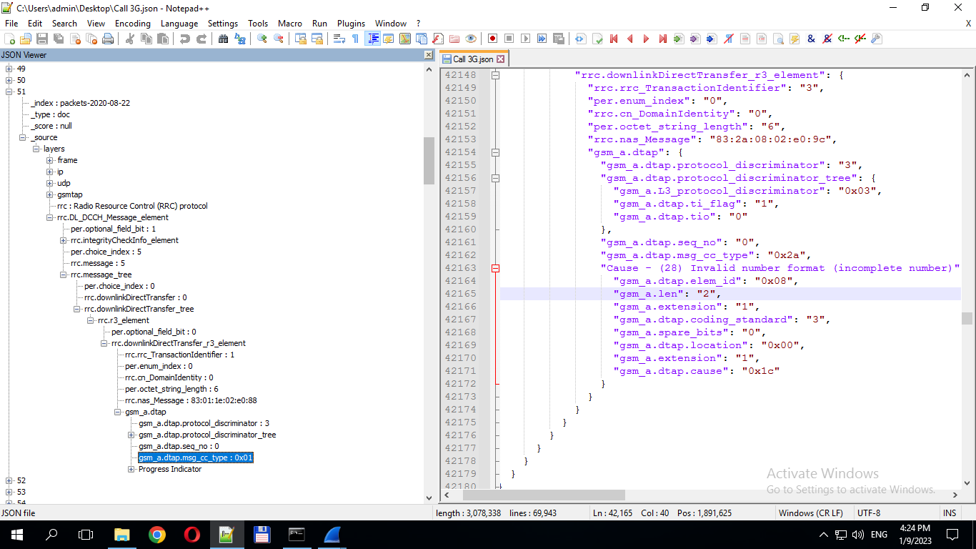 | (CC) Alerting | Call Alert
 |  |  |  |  |  |  | 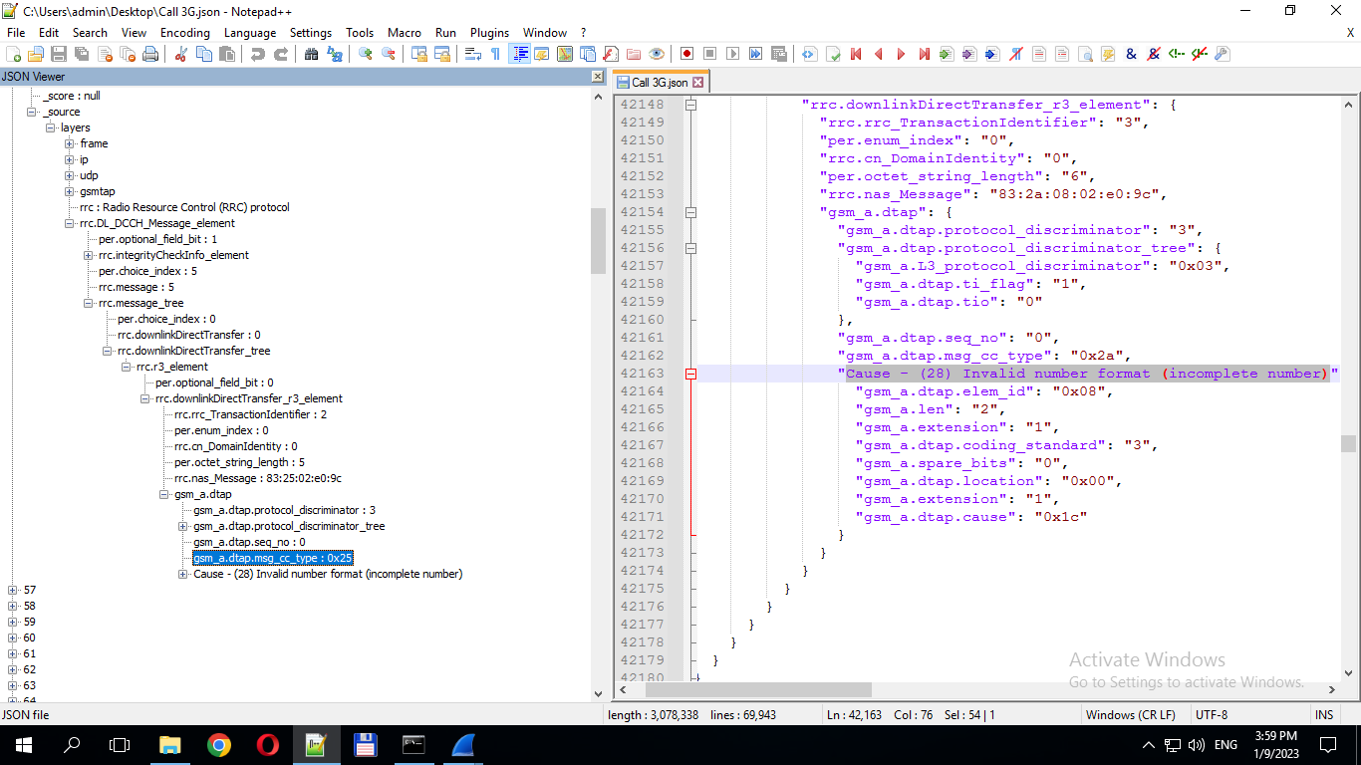 | (CC) Disconnect | Call Disconnect
 |  |  |  |  |  | Rrc.releaseCause : 0 | 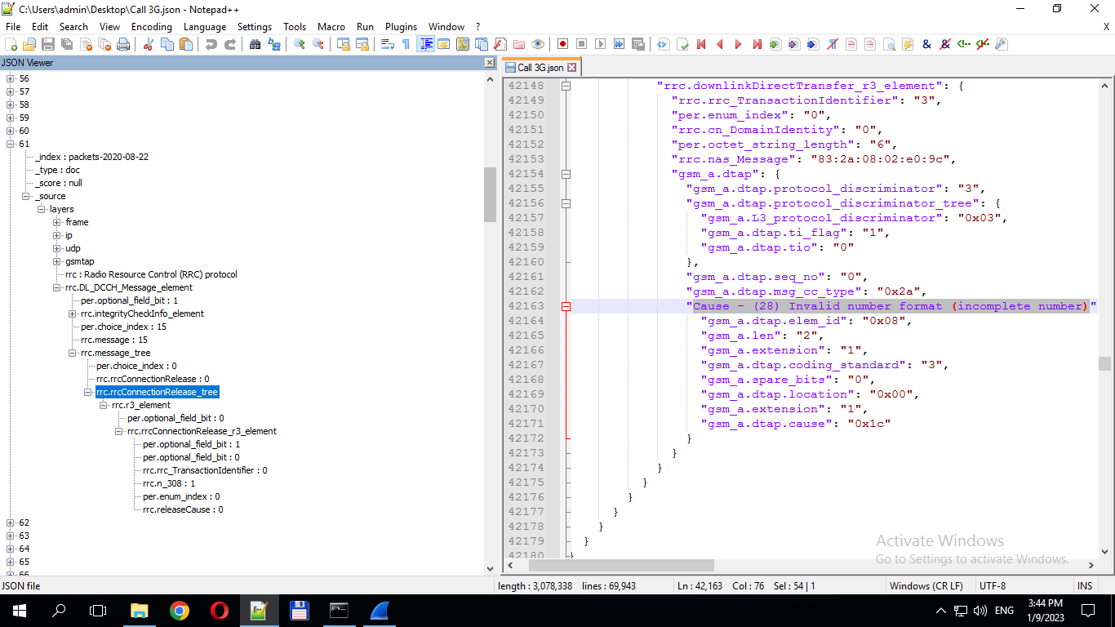 | WCDMA RRC Connection Release | WCDMA Call Release
 |  |  |  |  |  | lte-rrc.releaseCause": 1 | Lte_rrc→lte-rrc.rrcConnectionRelease_element | LTE RRC Connection Release
 |  |  |  |  |  |  | 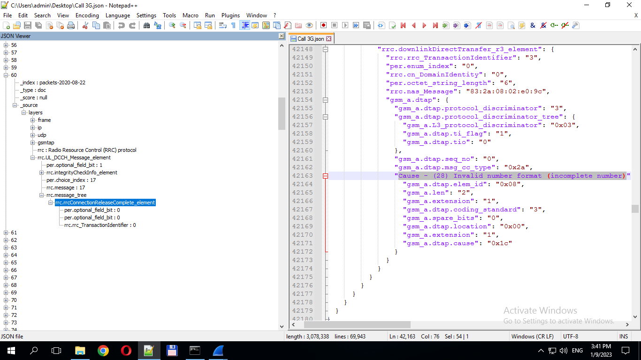 | WCDMA RRC Release Complete | WCDMA Call End

